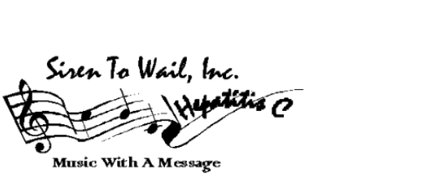

Donation Information Form
"Siren To Wail" 2nd Annual Hepatitis C Awareness Benefit Concert

When: Friday November 30th, 2000
Where: Howlin’ Wolf 828 S. Peters St. New Orleans
Awareness Concert: 8:00 p.m. until – Catered Buffet Silent Auction

Howlin’ Wolf

"Rajun Cajun" Doug Kershaw leads an all-star line-up including his brother Pee Wee Kershaw, Ben Keith producer and long time band member for Neil Young, Rockin' Dopsie, Marva Wright, Charmaine Neville, David Torkanowsky, Walter "Wolfman" Washington, Timothea, James Rivers, Eddie Bo, Leslie Smith, Sunpie Barnes, Ravi, Barbara "I Know" George, Bamboula 2000, and Brian Stoltz of the Meters, Chief Smiley Ricks, Veda Love, and many more. Hosted by WWL TV'S Eric Paulsen and Louisiana Music Commissioner Bernie Cyrus. A musical tribute will be performed in memory of Rusty Kershaw who passed on October23rd, 2001

Can your business donate goods or services -OR - sponsor the cost of promotional items, printing, T-Shirts, TV, Radio or ads to support and promote the "Siren To Wail" Hepatitis C Benefit Concert (Please complete this form)

I would like to donate:

Description Market Value

❍ Cash/Check $ _______________ $

❍ Art __ $

❍ Advertising _________ $

❍ Gift Certificate ___________________________________________ $_______

❍ Other ___________________________________________ $________

Donor/Contact Name: Title:
Organization:
Address:
City: State: Zip: Email:
Phone: ( ) Fax: ( )

Please mail or fax this form to Siren To Wail Inc. 4026 Annunciation St. New Orleans, La. 70115 504-891-4164 www.SirenToWail.Org Confirmation and pick up instructions will be sent to you after this form is received. If donating cash/check please fill out and return this form with your donation. Siren To Wail Inc. is a non-profit organization that promotes prevention, education, and awareness of the Silent Epidemic Hepatitis C. Thank you.

